 | Faculty of Information Science and Technology  Universiti Kebangsaan Malaysia  43600 Bangi  Selangor
GROUP NAME: RISING STAR
PROJECT TITLE: UKM Study Assistant
Final Report
TUTORIAL SET: 5
INSTRUCTOR NAME: MR.RAYHAN KABIR
GitHub link: https://github.com/a207355-design/ukm-study-assistant

Group Members:
Name & Matric Number |  | Contact Number & Email
WANG ZHENYU |  | 0147456027  A207338@siswa.ukm.edu.my
YANG KAI |  | 0176491642  A207408@siswa.ukm.edu.my
LIU ZHAOHE |  | 0177262347  A207395@siswa.ukm.edu.my
LEIAO |  | 0142723070  A207416@siswa.ukm.edu.my
SUN HUAYI |  | 01112425798  A207355@siswa.ukm.edu.my

Table of content
1. Introduction 4
1.1 Purpose 4
1.2 Scope 4
1.3 Overview 5
1.4 Definition 6
2. Project Scope 6
2.1 Problem & Opportunity 6
2.2 Goals 6
2.3 Objectives 7
2.4 Success Criteria 8
2.5 Assumptions 9
2.6 Constraints 10
3. Project Management 11
3.1 Development Methodology 11
3.2 Task Distribution (RASCI Matrix) 12
3.3 Gantt Chart 14
3.4 Burn Down Chart 15
3.5 Milestone Trend Chart (MTC) 16
3.6 Jira Implementation 17
3.7 GitHub Activity ………………………………………………………………………….19
3.8 Work Breakdown Structure (WBS) 20
3.9 Recommendation Analysis 21
4. System Design 22
4.1 Requirement Breakdown Structure (RBS) 22
4.2 Use Case Diagram 23
4.3 Class Diagram 24
4.4 Activity Diagram 25
4.5 Sequence Diagram 26
4.6 Data Flow Diagram (Level 0 & 1) 27
4.7 System Flowchart 28
4.8 Entity Relationship Diagram (ERD) 29
5. System Implementation 30
5.1 Tools and Technologies 30
5.2 System Architecture 30
5.3 Module Description 31
5.3.1 AI Chat Assistant 31
5.3.2 Schedule Management 31
5.3.3 Campus Events Module 31
5.3.4 UKM Website Navigation 31
5.3.5 Campus Map Navigation 32
5.3.6 User Profile Module 32
5.3.7 Data Management 32

6. Project Status report 33
6.1 Completed Features 33
6.2 In Progress Features 35
6.3 Challenges During Development 35
6.3.1 Technical Challenges 35
6.3.2 Data Storage Challenges 36
6.3.3 User Interface Challenges 36
6.3.4 Team Coordination Challenges 36
7. Software Testing 37
7.1 Testing Approach 37
7.2 Functional Testing 37
8.Website UI Design 39
9. Business analysis 41
9.1 Cost Benefit Analysis 41
9.1.1Cost Analysis 41
9.1.2 Direct Costs 41
9.1.3 Operational Costs 42
9.1.4 Intangible Costs 42
9.2 Benefit Analysis 43
9.2.1 Tangible Benefits 43
9.2.2 Intangible Benefits 43
9.3 Total Cost and Total Benefit 43
9.4 Net Benefit 44
9.5 Benefit-Cost Ratio (BCR) 44
9.6 Payback Period 44
9.7 Discussion 44
9.8 Conclusion 45
9.9 Summary Table 45
9.10 Earned Value Analysis (EVA) 46
10. Discussion & Challenges 47
10.1 Technical Issues 47
10.2 Team Coordination Issues 48
10.3 Solutions and Improvements 48
11. Conclusion 49
11.1 Summary of Project 49
11.2 Objectives Achievement 49
11.3 System Effectiveness 49
12. References 50

1. Introduction

1.1 Purpose

This document describes the software requirements for the UKM Study Assistant, a smart campus assistant system designed for Universiti Kebangsaan Malaysia (UKM) students.

The system integrates AI-based interaction, personal schedule management, and campus event aggregation into one platform to improve students ’daily productivity and campus
experience.

1.2 Scope

1. The primary goal of this project is to develop a functional system called UKM Study Assistant by the end of the development period.
2. The system aims to assist students by integrating AI-based interaction, schedule management, and campus event information into a single platform.
3. The system will focus on improving students ’productivity, time management, and access to campus-related information.
4. If time permits, additional enhancements such as improved user interface and usability features will be implemented.
5. If the project scope becomes too large, the development will prioritize the core functionalities, including:
o AI chat assistant
o Schedule management and reminder system
o Campus event aggregation
6. The system will support a complete workflow, from data input (e.g., adding schedules) to output (e.g., reminders and AI responses).
7. The system will be designed with extensibility in mind, allowing future developers to add new features such as user authentication, data analytics, and personalization.
8. The system also aims to address common student problems, such as:
o Forgetting class schedules
o Difficulty accessing campus event information
o Lack of personalized academic assistance
9. The final system is expected to be stable, user-friendly, and scalable for future improvements.

1.3 Overview

The UKM Study Assistant is a web-based platform designed to enhance student
productivity and campus navigation by integrating several key modules into a unified system.
Key features include:
• AI Chat Assistant: Provides real-time academic support via the DeepSeek API.
• Schedule & Reminders: Enables class management with automatic notifications 30 minutes before sessions.
• Campus Updates: Retrieves real-time events and news using RSS data sources.
• Navigation Tools: Offers quick access to official UKM websites and interactive campus maps.
• Local Storage: Uses JSON files for lightweight, efficient management of schedules and chat history.
Overall, the system simplifies campus life by centralizing essential academic and information services into a single, intelligent assistant.
1.4 Definition
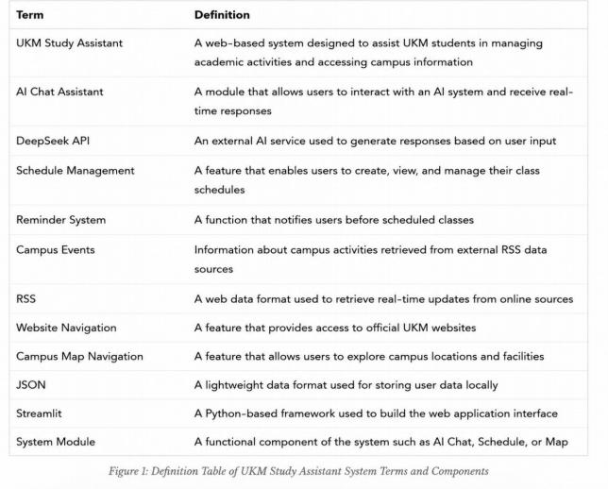

2. Project Scope

2.1 Problem & Opportunity

Here is a concise version of your project background and problem statement:
The UKM Study Assistant is a web-based platform designed to enhance student
productivity and campus navigation by integrating several key modules into a unified system.
Core Problem & Solution
• Information Fragmentation: Students currently struggle with scattered information
across multiple platforms. This system centralizes official UKM websites and real-time campus events via RSS data sources.
• Ineffective Schedule Management: To prevent missed classes, the system provides a Schedule Management module with automatic reminders 30 minutes before sessions.
• Navigation Difficulties: Especially for new students, the Campus Map Navigation feature simplifies locating faculties and facilities across the large UKM campus.
• Lack of Personalized Help: The AI Chat Assistant, powered by the DeepSeek API, offers instant, context-aware academic assistance.
• Key Technical Features
• Integrated Workflow: Combines AI interaction, schedule tracking, and news aggregation in a single interface.
• Efficient Data Handling: Uses JSON files for lightweight local storage of schedules and chat history.
• User-Centric Design: Optimized for desktop browsers to ensure a stable and reliable user experience.
By addressing these challenges, the UKM Study Assistant simplifies campus life, improves time management, and fosters a more efficient academic environment.

2.2 Goals

The primary goal of the UKM Study Assistant is to develop a centralized, intelligent web
platform that integrates AI interaction, schedule management, and campus navigation. By unifying these tools, the project aims to enhance student productivity, improve time
management, and simplify access to campus-related information.

2.3 Objectives

The specific objectives of the UKM Study Assistant are:
• AI Interaction: Develop a chatbot using the DeepSeek API for real-time responses.
• Schedule Management: Build a system to efficiently add, view, and manage class timetables.
• Automated Reminders: Implement notifications to alert users before their scheduled classes.
• Event Tracking: Create a module to retrieve and display campus activities via RSS data sources.
• Advanced Search: Include search and filtering functions to improve event usability.
• Quick Navigation: Provide a feature for fast access to official UKM websites.
• Map Module: Develop a navigation tool to help students locate faculties and key campus sites.
• Profile Customization: Enable users to personalize their display names and avatars.
• Lightweight Storage: Use JSON to store schedules and chat history locally.
• Modular Architecture: Design a scalable system structure that supports future functional updates.

2.4 Success Criteria

The success of the UKM Study Assistant system will be evaluated based on the following criteria:

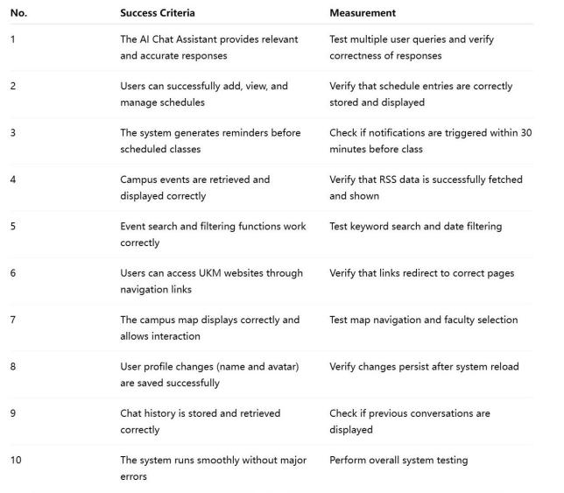
Figure2: Success Criteria and Measurement Table for UKM Study Assistant System

2.5 Assumptions

The development and operation of the UKM Study Assistant system are based on the following assumptions and dependencies:
1. It is assumed that users have basic knowledge of using web applications and can interact with the system through a browser.
2. It is assumed that users will input accurate schedule data for the system to provide correct reminders and AI responses.
3. The system depends on the availability of the DeepSeek API for generating AI-based responses. Any downtime or performance issues may affect system functionality.
4. The system depends on external RSS data sources to retrieve campus events. Changes in the data format or availability may impact the system.
5. The system requires a stable internet connection to function properly, as both AI interaction and event retrieval rely on online services.
t
6. The system assumes that the local JSON storage is accessible and not corrupted, as i is used to store user schedule data.
7. The system does not currently include user authentication; therefore, it assumes that the user accessing the system is the intended user.
8. The system assumes that external UKM websites used for navigation are available and accessible. Any changes in website structure may affect navigation functionality.
9. The system assumes that map-related resources are available and can be accessed when users interact with the campus map feature.
10. The system assumes that local storage is sufficient to store chat history and user data without data loss.

2.6 Constraints

The development of the UKM Study Assistant system is subject to several design and implementation constraints.
1. The system must be developed using the Python programming language and the Streamlit framework, as these technologies are chosen for simplicity and rapid
development.
2. The system must integrate with the DeepSeek API to provide AI-based responses. Therefore, the functionality of the system depends on the availability and
performance of the external API.
3. The system relies on RSS data sources for retrieving campus events. Any changes or disruptions in the RSS feed structure may affect the system functionality.

4. external services such as the AI API, RSS data sources, and web resources for navigation and map features
5. The system uses JSON files for data storage instead of a traditional database, which limits scalability for large-scale data management.
6. The system is designed to run on desktop environments only and is not optimized for mobile devices.
7. The system must handle potential network failures gracefully by providing fallback data or error messages.
8. The system depends on external web resources for website navigation. Any
changes in the structure or availability of UKM websites may affect navigation functionality.
9. The system stores chat history locally using JSON files, which may be limited by storage capacity and data management constraints.

3. Project Management

3.1 Development Methodology

Software Development Life Cycle (SDLC)
The development of the UKM Study Assistant follows the Software Development Life
Cycle (SDLC) to ensure a structured and systematic approach. The project progresses through key phases including planning, requirements analysis, system design,
implementation, testing, and deployment.
Each phase contributes to building a stable and functional system, ensuring that all requirements are properly translated into the final application.

Agile Methodology
The project adopts an Agile methodology to support iterative development through the following objectives:
•Iterative Development: Build core features (AI chat, schedule, events) first, followed by secondary enhancements like map navigation and UI improvements.
•Flexibility & Feedback: Use an iterative approach to adapt to changes and continuously incorporate user feedback.
•Team Collaboration: Maintain structured roles, including Scrum Master, developers, and a tester, to ensure efficient progress.
•Structured Lifecycle: Combine SDLC for project structure with Agile for execution flexibility.

Relationship between SDLC and Agile
SDLC provides the overall structure of the project, while Agile defines how the
development process is carried out in an iterative and flexible manner. Together, they ensure both organization and adaptability in the system development.

3.2 Task Distribution (RASCI Matrix)

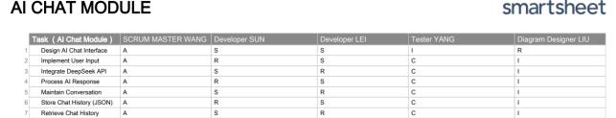
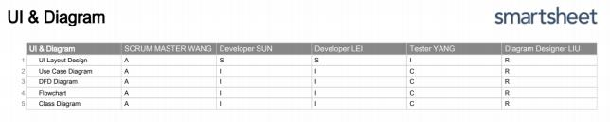
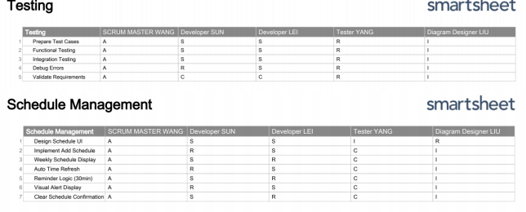
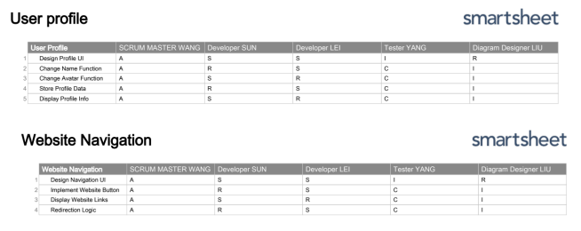

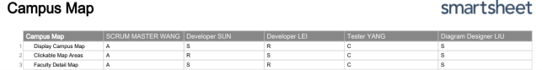

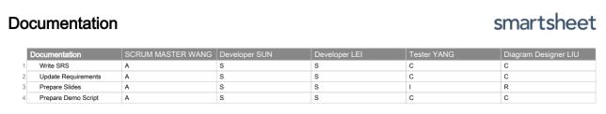

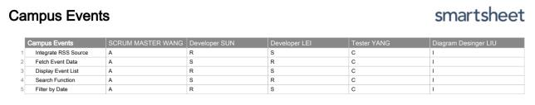

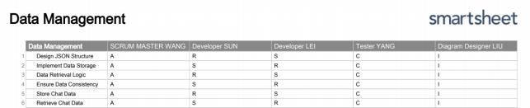

Figure 3: Task Distribution (RASCI Matrix)

3.3 Gantt Chart
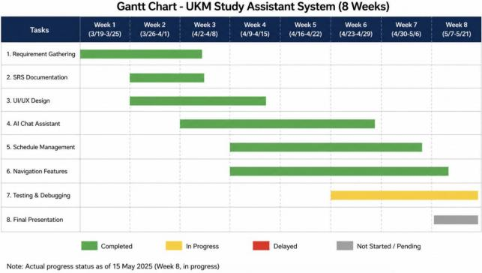

Figure4: Gantt Chart Showing Development Timeline of UKM Study Assistant Project

Gantt Chart Analysis

The Gantt Chart shows the planned and actual progress of the UKM Study Assistant project over an 8-week development period.

At the beginning of the project, Requirement Gathering and SRS Documentation were completed according to the planned schedule. UI/UX Design was also completed
successfully during the early development phase.

During the middle phase of the project, the development of the AI Chat Assistant,
Schedule Management, and Navigation Features progressed steadily and most tasks were completed on time. Minor delays occurred due to API integration issues, debugging
activities, and reduced team availability during the holiday period.

Currently, Testing & Debugging is still in progress as the team continues improving system stability and fixing minor issues. The Final Presentation preparation has not yet started
because the team is prioritizing final testing and documentation.

Overall, the project remains generally on track, with most core modules completed successfully and no major schedule deviation observed.

3.4 Burn Down Chart

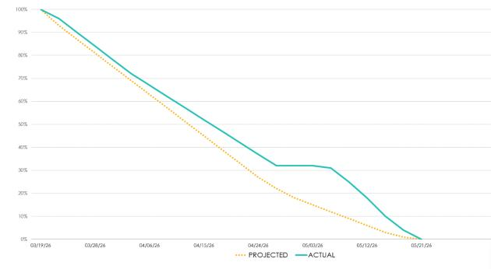
Figure5: Burndown Chart Showing Remaining Project Tasks Across Development Weeks

The burndown chart shows that the team was generally on track in completing the project tasks throughout the development period.

At the beginning of the project, the remaining work decreased steadily because the team completed planning, requirements analysis, and early development tasks. During the
middle phase, the progress slowed down slightly due to a short holiday period and reduced team availability.

After that, the team continued completing the remaining development and testing tasks. Overall, the project remained manageable and was completed according to the planned schedule, with the remaining work reaching 0% by the end of the project period.

3.5 Milestone Trend Chart (MTC)

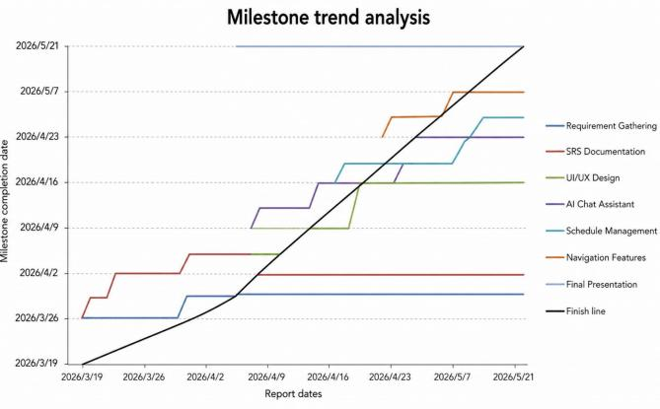
Figure6: Milestone Trend Chart Comparing Planned and Actual Project Progress

The Milestone Trend Chart (MTC) shows the comparison between the planned milestone dates and the actual project progress throughout the development of the UKM Study
Assistant System.
Overall, the project milestones were generally achieved close to the planned schedule.
Early milestones such as Requirement Gathering, SRS Documentation, and UI/UX Design were completed on time due to effective task distribution and proper planning among team members.
During the middle development phase, modules such as AI Chat Assistant and Schedule Management experienced slight delays because of integration and debugging challenges. In addition, academic commitments and public holiday periods affected the consistency of development activities, causing minor schedule adjustments.
The final stages, including Testing & Debugging and Final Presentation preparation, were still in progress during the latest reporting period. However, the overall project remained within acceptable progress limits and no major milestone deviation occurred.
Based on the MTC analysis, the team was able to maintain relatively stable project progress while adapting to development challenges and schedule constraints.

3.6 Jira Implementation

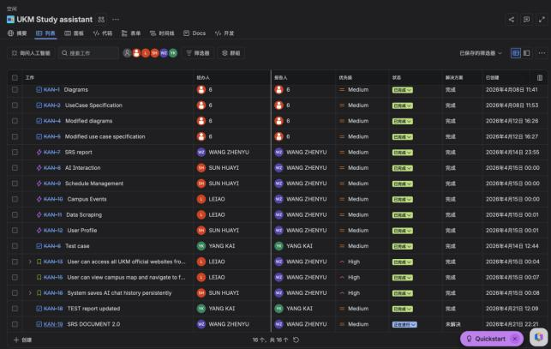

Figure7.1: Task List View of UKM Study Assistant Project in Jira Showing Assigned Tasks, Status, and Priority Levels

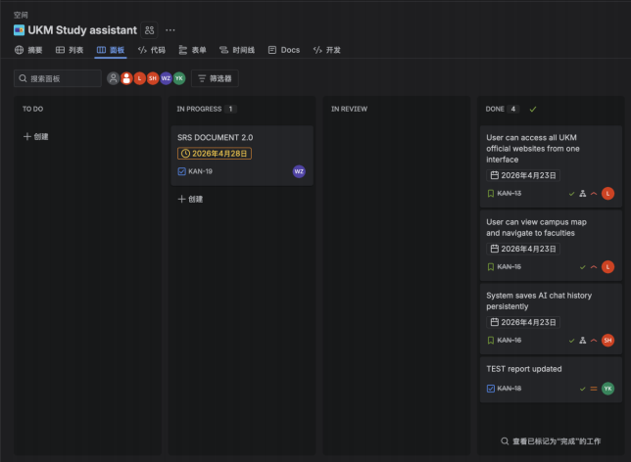

Figure7.2: Kanban Board View of UKM Study Assistant Project Showing Task Progress (To Do, In Progress, Done)

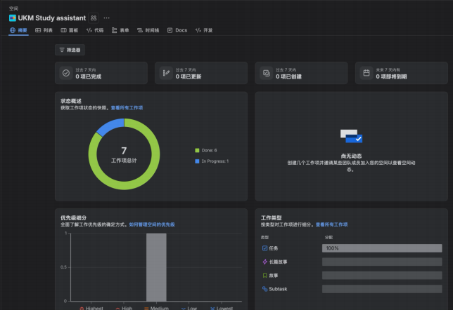

Figure7.3: Project Dashboard Showing Task Distribution and Progress Statistics of UKM Study Assistant

3.7 GitHub Activity

The UKM Study Assistant project was managed using GitHub for version control and source code management. The repository contains the implementation of the system modules, development history, and project updates throughout the development process.

GitHub Repository:
https://github.com/a207355-design/ukm-study-assistant

GitHub Repository Screenshot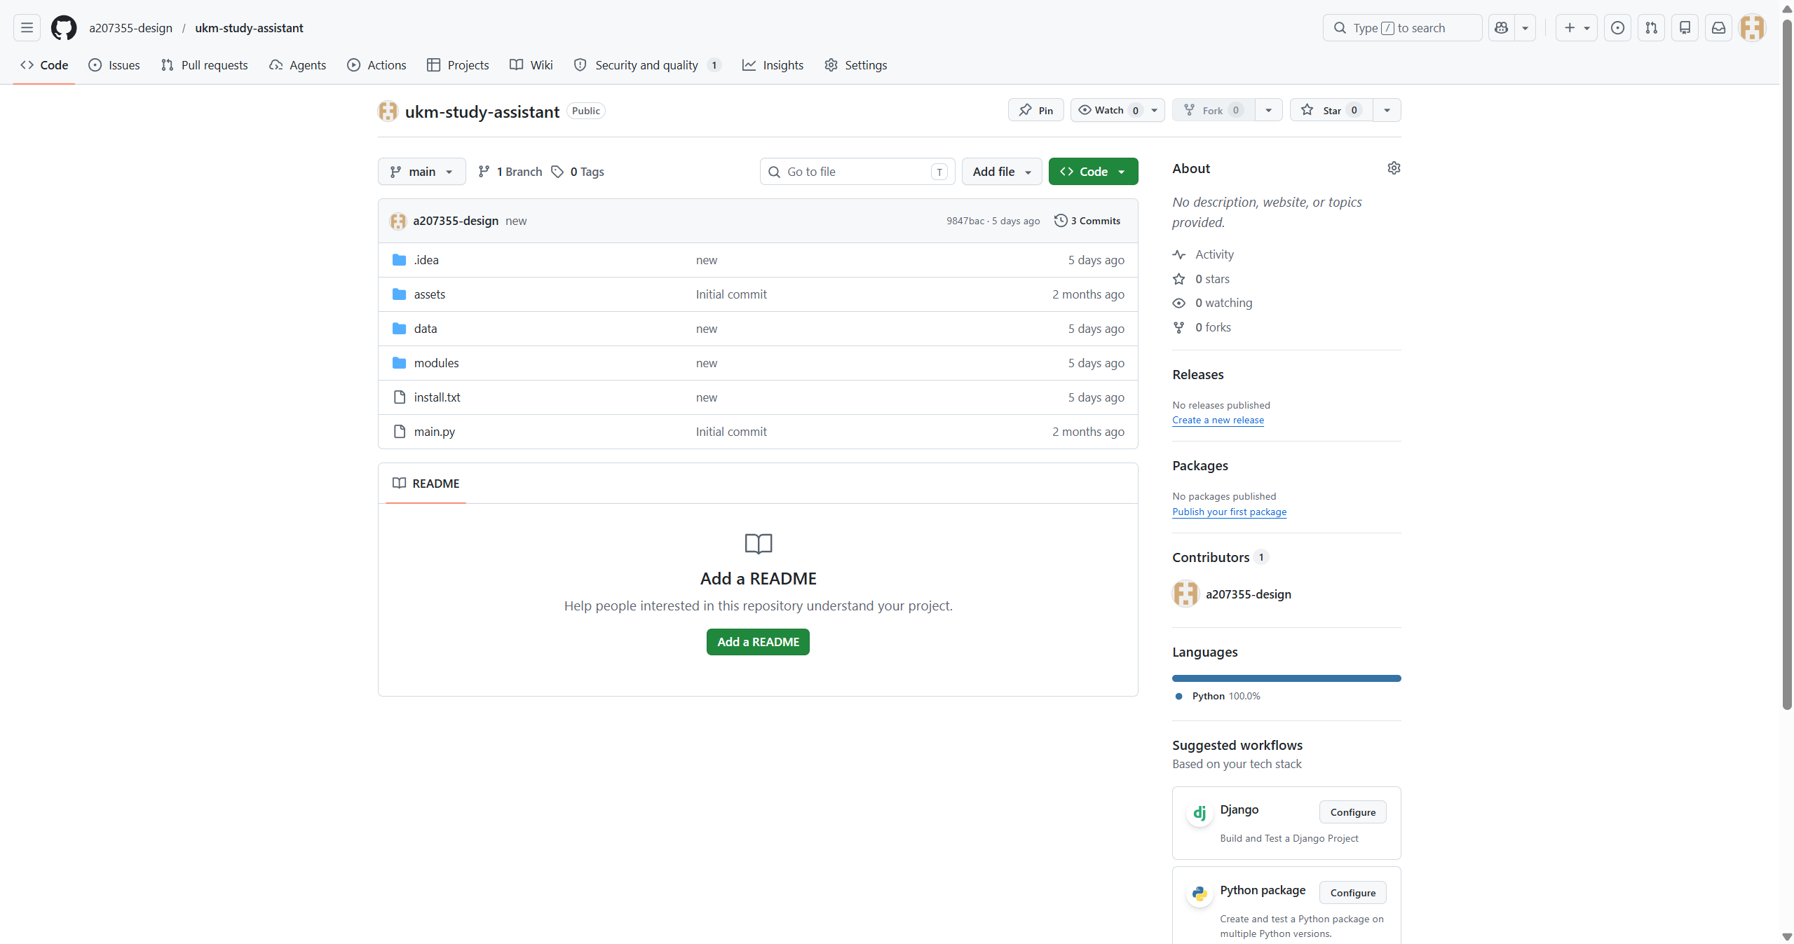

3.8 Work Breakdown Structure (WBS)

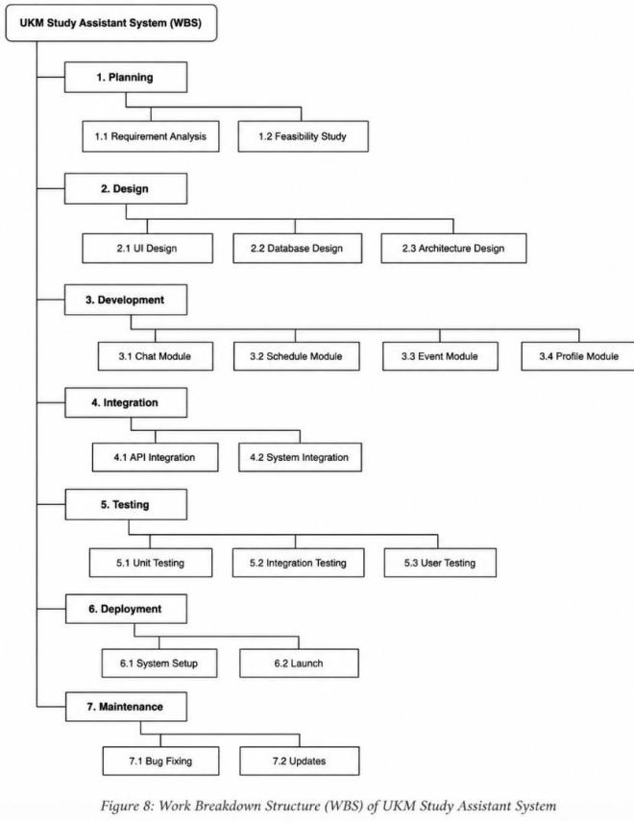

3.9 Recommendation Analysis

The UKM Study Assistant System was successfully developed with most core features functioning properly. However, several recommendations can be considered for future improvement.

Firstly, the system can be enhanced by implementing a database management system
such as MySQL or Firebase instead of relying on local JSON storage. This would improve scalability, data security, and multi-user support.
Secondly, the AI Chat Assistant can be improved by integrating more advanced natural language processing capabilities and supporting multilingual responses to better assist international students.

In terms of project management, more frequent team meetings and progress monitoring sessions are recommended to reduce delays during the development phase. Better task distribution and earlier testing activities may also help improve development efficiency. Additionally, future development may include mobile application support, push
notifications, and real-time synchronization features to improve user accessibility and overall user experience.

Overall, the project has achieved its main objectives, but continuous improvements and feature expansion are recommended for future system enhancement.

4. System Design

4.1 Requirement Breakdown Structure (RBS)

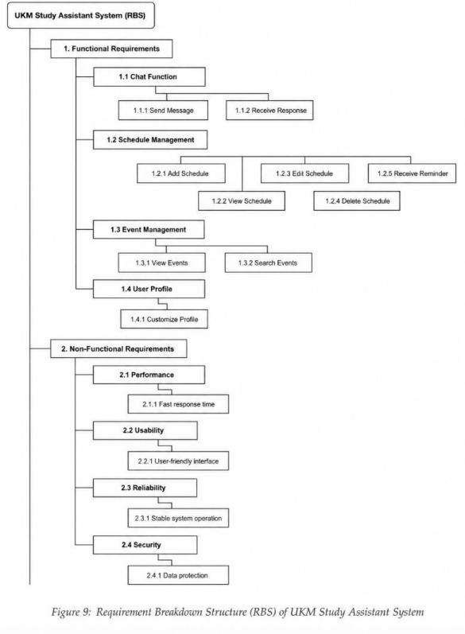

4.2 Use Case Diagram

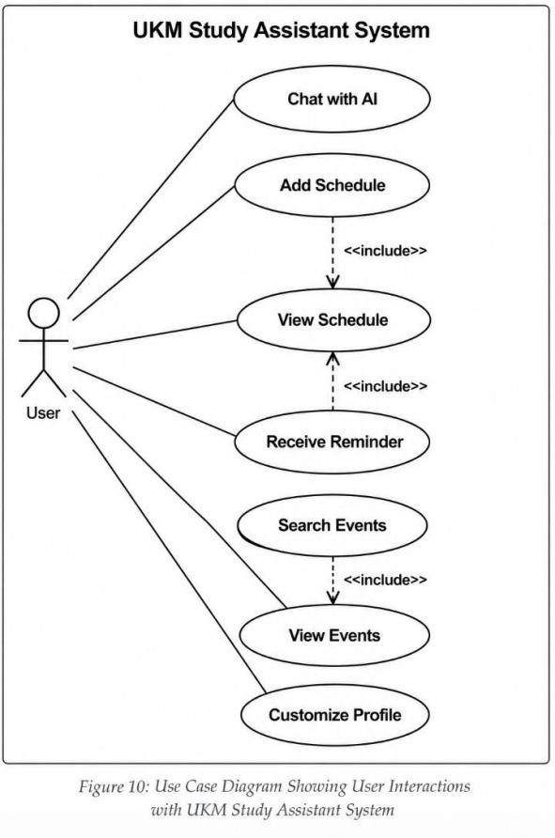

4.3 Class Diagram

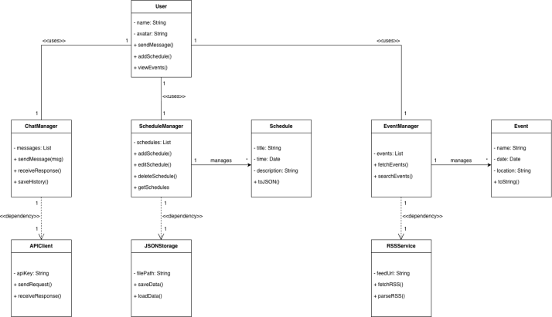
Figure11: Class Diagram Showing Relationships Between System Components

4.4 Activity Diagram

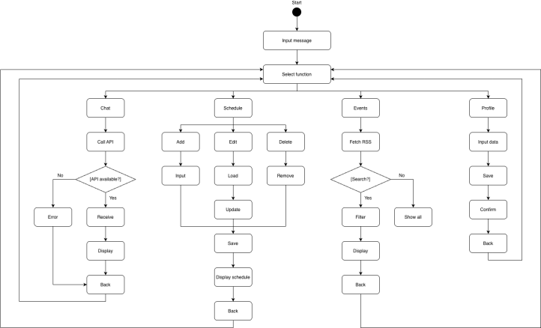

Figure12: Activity Diagram Showing User Workflow of UKM Study Assistant System

4.5 Sequence Diagram

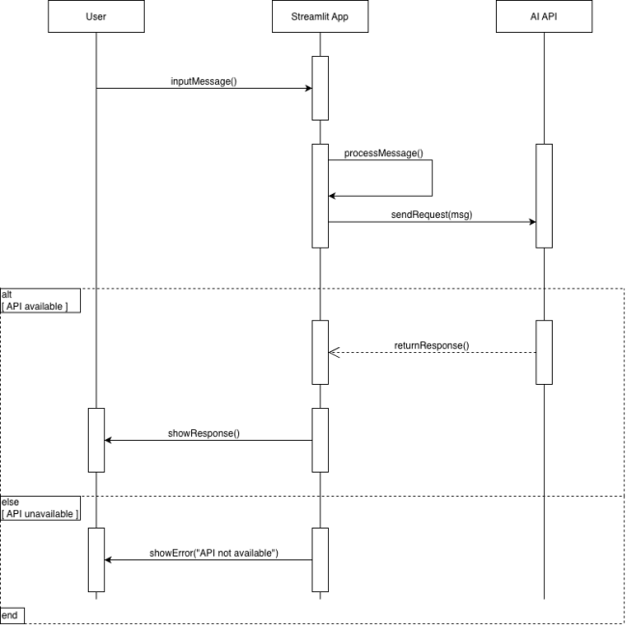
Figure13: Sequence Diagram Showing Interaction Between User, System, and AI API

4.6 Data Flow Diagram (Level 0 & 1)

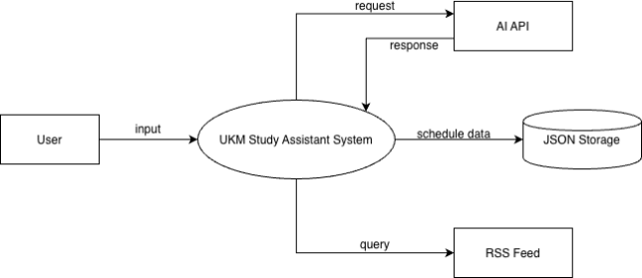

Figure14.1: Data Flow level 0 Diagram Showing Information Flow Within UKM Study Assistant System

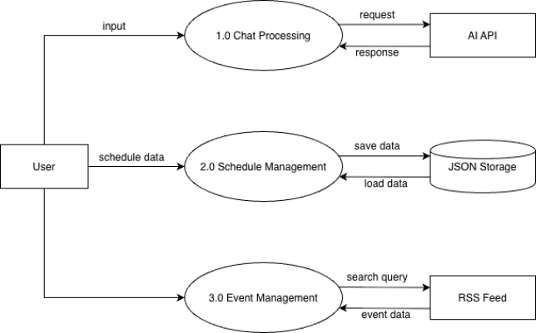
Figure14.2: Data Flow level 1 Diagram Showing Information Flow Within UKM Study Assistant System

4.7 System Flowchart

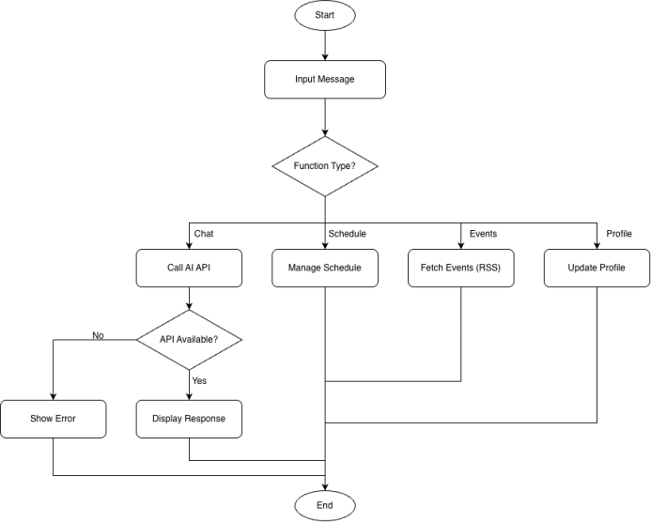

Figure15: System Flowchart Showing Overall Process Flow of UKM Study Assistant System

4.8 Entity Relationship Diagram (ERD)

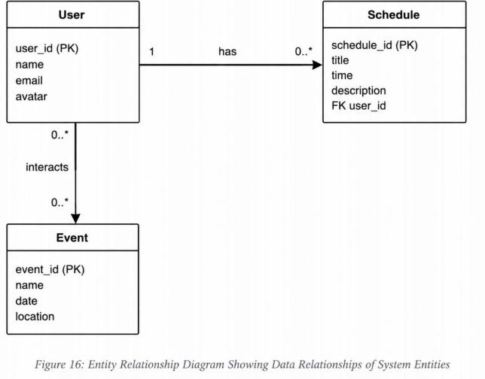

5. System Implementation

5.1 Tools and Technologies

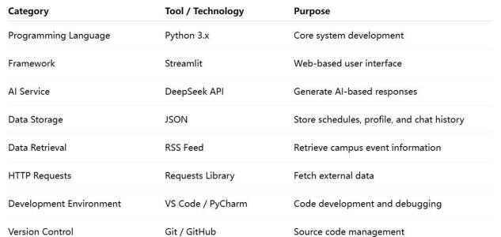
Figure17: Tools and Technologies Used in UKM Study Assistant Development

5.2 System Architecture

The UKM Study Assistant utilizes a modular, web-based architecture powered by the Streamlit framework.
Architecture Overview
• Framework: Streamlit simplifies development by merging frontend and backend logic into a single Python workflow.
• Modular Design: The system includes independent modules for AI Chat, Schedule Management, Campus Events, Website Navigation, Campus Map, and User Profile.
• External Integration: It connects to the DeepSeek API for AI responses and RSS feeds for real-time events.
• Lightweight Storage: Data such as schedules and chat history is managed via local JSON files, eliminating the need for complex databases.
• System Benefits
• Efficiency: Ensures low complexity and rapid development.
• Maintenance: High cohesion and low coupling allow for easy updates and future scalability.

5.3 Module Description

5.3.1 AI Chat Assistant

The AI Chat Assistant module allows users to interact with the system using natural language.

User input is sent to the DeepSeek API, which processes the request and generates a response. The system then displays the response in the chat interface.

Additionally, the system maintains conversation context and stores chat history locally using JSON, allowing users to retrieve previous interactions.

5.3.2 Schedule Management

The Schedule Management module enables users to add, view, and manage their class schedules.

Users can input course details, which are stored in JSON format. The system displays schedules in a structured weekly view.

A reminder function is implemented to notify users 30 minutes before scheduled classes.

5.3.3 Campus Events Module

This module retrieves campus event information using RSS data sources.

The system processes RSS data and displays a list of events. Users can search and filter events based on keywords or date range.

5.3.4 UKM Website Navigation

This module provides quick access to UKM official websites.

Users can click buttons to view a list of links and are redirected to the selected website.

5.3.5 Campus Map Navigation

The Campus Map module allows users to view and interact with the UKM campus map.

Users can select different faculties, and the system displays detailed information or maps for the selected location.

5.3.6 User Profile Module

This module allows users to customize their profile by changing their display name and avatar.

All profile data is stored locally in JSON format and displayed in the interface.

5.3.7 Data Management

The system uses JSON files to store:
Schedule data Chat history
User profile

This approach simplifies data management and eliminates the need for a database.

6. Project Status report

Project Title
UKM Study Assistant

Reporting Period
Week 1 – Week 8

Overall Project Status
On Track

The project is progressing according to the planned schedule. Most core modules have been successfully implemented and tested, including AI Chat Assistant, Schedule
Management, and Campus Event features. Minor issues related to API stability and data synchronization are currently being monitored.

6.1 Completed Features

The development of the UKM Study Assistant has achieved several core functions based on the system requirements defined in the SRS document. Most of the main modules have been implemented and tested during the development process.

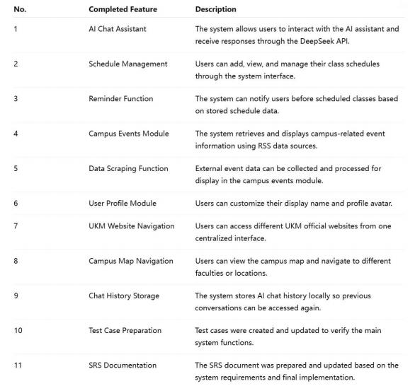
Figure18: Completed Features Table of UKM Study Assistant System

6.2 In Progress Features

Although the main system functions have been completed, some improvements are still in progress to enhance the quality, usability, and maintainability of the system.

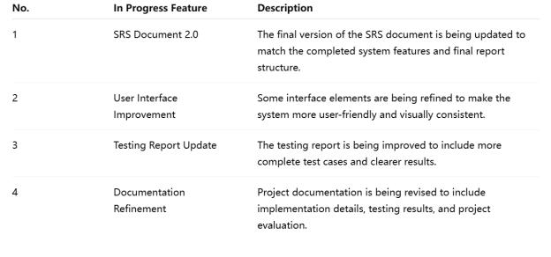
Figure19: In Progress Features Table of UKM Study Assistant System

6.3 Challenges During Development

During the development of the UKM Study Assistant, several challenges were
encountered. These challenges were related to technical implementation, data handling, user interface design, and team coordination.

6.3.1 Technical Challenges

Technical Challenges & Solutions
• API Integration: To address DeepSeek API latency and connection instability, the team implemented error handling to notify users if the service is unavailable.
• RSS Data Reliability: To manage unpredictable changes in RSS structures, the
scraping and retrieval functions were refined to ensure consistent display of campus events.

6.3.2 Data Storage Challenges

The system uses JSON files to store user data such as schedules, profiles, and chat history. Although JSON storage is simple and lightweight, it has limitations in terms of scalability and data consistency. The team needed to carefully manage read and write operations to prevent data loss or corrupted files.

6.3.3 User Interface Challenges

Since the system was developed using Streamlit, the team needed to design the interface within the limitations of the framework. Ensuring that the AI chat, schedule, events,
website navigation, map, and profile modules were easy to access from one platform required several interface adjustments.

6.3.4 Team Coordination Challenges

Team Coordination & Project Progress
• Task Distribution: The team divided the workload across specialized modules, including diagrams, SRS documentation, AI features, and testing.
• Project Management: Jira was utilized to assign tasks, track real-time progress, and monitor the development of core features.
• Implementation: Coding transformed SRS requirements into functional modules, ensuring alignment with the project plan.
• Outcome: These efforts strengthened collaboration and ensured most core functionalities were completed through a structured development process.

7. Software Testing

7.1 Testing Approach

The testing strategy for the UKM AI Assistant System combined manual functional testing with automated unit testing using Python’s unittest framework. Team members tested their assigned modules based on system workflows. Cross-browser testing was done on
Google Chrome and Microsoft Edge. User acceptance testing was simulated by team members taking different roles and checking full workflows end-to-end.

7.2 Functional Testing

The table below summarises the key functional test cases covering unit, system,
integration, performance, and error handling testing.

TC ID | Test Case | Expected Result | Actual Result | Status
TC01 | AI Chat with valid API key and schedule context | AI responds with correct course info from schedule | AI response matched stored schedule data | Pass
TC02 | Add new course via schedule form | Course saved to JSON; weekly view updated | Course saved and displayed correctly | Pass
TC03 | Add course with missing required fields | Error message shown; no data saved | Validation triggered; error displayed | Pass
TC04 | Delete all courses with confirmation | All courses removed; schedule shows empty | JSON cleared; empty schedule displayed | Pass
TC05 | Class reminder alert triggers within 30 minutes | Toast and error banner shown with course details | Reminder alert displayed with correct info | Pass
TC06 | Auto-refresh every 60 seconds | Page reloads; unsaved form input preserved | Page refreshed but unsaved input was lost | Fail
TC07 | News fetching with internet available | Up to 30 news items fetched and displayed | 30 items rendered with title, date, and link | Pass
TC08 | News keyword + date filter applied | Only matching items displayed | Filtered results matched both conditions | Pass
TC09 | News fetch under slow network conditions | Response within 5 seconds | Took 6–8 sec on slow campus Wi-Fi — exceeded target | Fail

TC ID | Test Case | Expected Result | Actual Result | Status
TC10 | Unauthorised/missing map image in Campus Guide | Warning shown; app does not crash | Warning displayed; page remained stable | Pass
TC11 | Create, rename, and delete chat session | Session updated and reflected in sidebar | All operations completed correctly | Pass
TC12 | Edit profile name and upload avatar | Profile saved; sidebar reflects changes | Username and avatar updated successfully | Pass

Functional Testing Discussion

Functional testing was conducted to verify whether each module of the application
behaved according to the system requirements. The testing covered AI chat integration, course scheduling, reminders, news services, error handling, and profile management.

Most test cases achieved the expected outcomes, indicating that the system is generally stable and functional. Features such as course creation, filtering, chat session
management, and validation handling performed correctly without major issues.

However, two limitations were identified:

l Unsaved form data was not preserved during automatic refresh.
l Network performance under slow internet conditions exceeded the target response time.

These findings suggest that additional optimization is required for state management and asynchronous data loading in future development.

8.Website UI Design

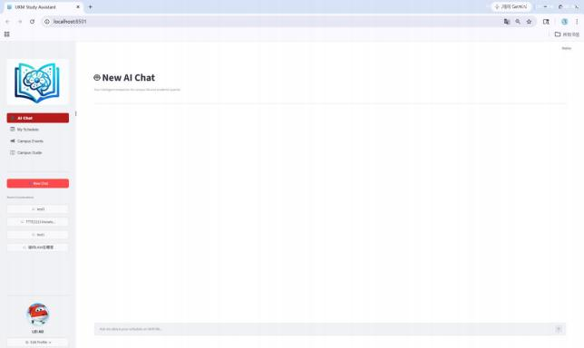
This image shows the homepage of the UKM Learning Assistant system. Users can use
this interface to initiate new conversations, view previous chat logs, and interact with the AI assistant. The sidebar provides quick access to different functions and chat sessions.
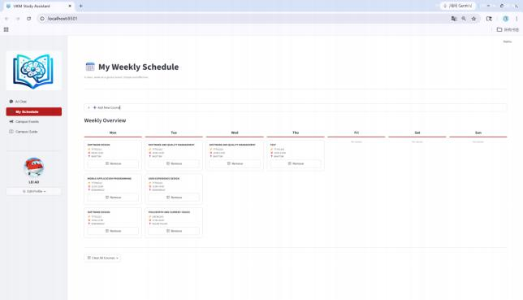
This image shows the website's weekly timetable interface. Users can add their own courses to the timetable, making it easier for them to check today's classes.

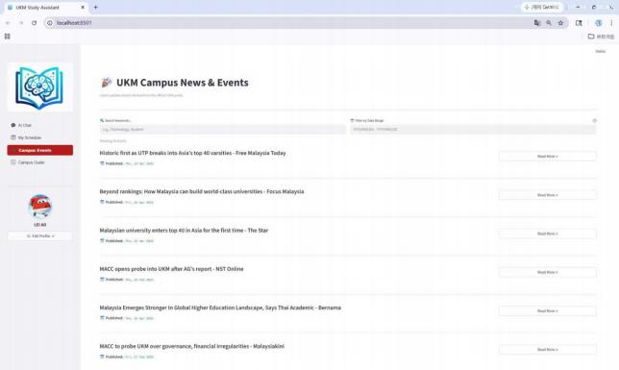
This image shows the system's "Campus News and Events" page. Students can browse the latest university news and announcements, search for specific topics, and read
detailed information via provided links.

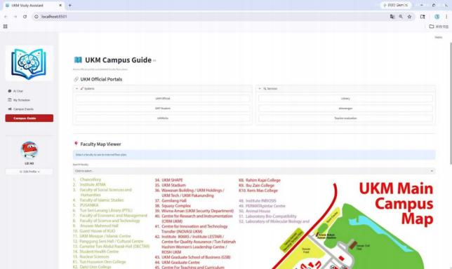
This image shows the campus guide interface. Users can use this interface to access the university's official websites, search for departments and campus locations, and view a
campus map for easier navigation.

9. Business analysis

9.1 Cost Benefit Analysis

9.1.1Cost Analysis

The costs of the project are categorized into direct costs, operational costs, and intangible costs.

9.1.2 Direct Costs

Item | Description | Estimated Cost (RM)
System Design | UI design, feature planning, and prototyping | 300
Front-end | Development of Streamlit interface and | 500
Development | user interaction
Back-end | Implementation of system logic and data | 400
Development | processing
AI Integration | Integration and testing of DeepSeek API | 350
Web Crawler | Development of campus news crawling | 300
Development | function
Map Module | Development of campus map and | 250
Development | navigation feature

Total Direct Costs = RM 2,100

9.1.3 Operational Costs

Item | Description | Estimated Cost (RM)
Hosting and  Deployment | Basic server or hosting services | 300
API Usage | Cost of AI service requests | 250
Maintenance | Bug fixing and system updates | 300
Data Updates | Updating campus information and map data | 150
Total Operational Costs = RM 1,000

9.1.4 Intangible Costs

• Users may require time to learn how to use the system effectively.
• The accuracy of crawled data may vary or be delayed.
• The system depends on external services (AI APIs) and internet connectivity.
• Continuous maintenance is required if the system is used long-term.
Although these costs cannot be directly measured in monetary terms, they may affect the overall performance and sustainability of the system.

9.2 Benefit Analysis

The benefits of the system are divided into tangible and intangible benefits.

9.2.1 Tangible Benefits

Item | Description | Estimated Value (RM)
Time Saving | Reduces time spent searching for schedules and information | 1,200
Reduced Search Effort | Multiple functions integrated into one platform | 900
Reduced Dependence on Manual Reminders | Less reliance on friends or chat groups | 700
Improved Academic Efficiency | Automatic reminders reduce missed classes | 1,000
Total Tangible Benefits = RM 3,800

9.2.2 Intangible Benefits

• Improved overall student experience
• Reduced confusion for new students through navigation features
• Better access to updated campus information
• Promotion of digitalization and innovation in campus services
• Increased confidence in managing academic schedules

9.3 Total Cost and Total Benefit

Total Cost
Total Cost = Direct Costs + Operational Costs Total Cost = RM 2,100 + RM 1,000 = RM 3,100

Total Benefit
Total Benefit = RM 3,800

9.4 Net Benefit

Net Benefit = Total Benefit – Total Cost
Net Benefit = RM 3,800 – RM 3,100 = RM 700
This indicates that the project generates a positive return.

9.5 Benefit-Cost Ratio (BCR)

BCR = Total Benefit / Total Cost BCR = 3,800 / 3,100 ≈ 1.23
Since the BCR is greater than 1, the project is considered feasible and worthwhile.

9.6 Payback Period

Payback Period = Initial Cost ÷ Annual Benefits= 3100 ÷ 3800 ≈ 0.82 years

This means the project can recover its cost in less than 1 year.

9.7 Discussion

Benefit Analysis Summary
• Tangible Benefits: Provides measurable gains through time savings and improved academic efficiency.
• Intangible Benefits: Enhances user experience, improves access to campus resources, and reduces confusion for new students.
• User Impact: Simplifies campus life by integrating multiple features into a single, convenient platform.
• Feasibility: Despite development and maintenance efforts, the overall benefits outweigh the costs, offering a practical solution for student support.

9.8 Conclusion

Conclusion & Feasibility
• Financial Viability: The project is financially feasible with a total cost of RM 3,100, a total benefit of RM 3,800, and a net benefit of RM 700.
• Efficiency: The Benefit-Cost Ratio (BCR) stands at 1.23, indicating a positive return on investment.
• Problem Solving: The system effectively addresses missed class reminders, navigation difficulties, and fragmented information access.
• Impact: Beyond being cost-effective, the project significantly improves student life and academic efficiency on campus.
•

9.9 Summary Table

Category | Amount (RM)
Total Direct Costs | 2,100
Total Operational | 1,000
Costs
Total Costs | 3,100
Total Tangible
Benefits | 3,800
Total Benefits | 3,800
Net Benefit | 700
Benefit-Cost Ratio | 1.23

9.10 Earned Value Analysis (EVA)

Earned Value Analysis (EVA) is used to evaluate the project performance by comparing the planned work, completed work, and actual cost. For the UKM Study Assistant project, EVA helps the team determine whether the project is on schedule and within budget.

EVA Assumptions

The total project budget is based on the total project cost calculated in the Business
Analysis section, which is RM 3,100. At the current reporting stage, the project was
planned to complete 80% of the total work. Based on the completed modules and testing progress, the actual completed work is estimated at 75%. The actual cost used so far is estimated at RM 2,900.

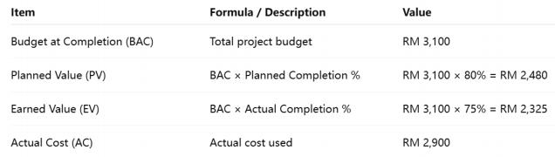

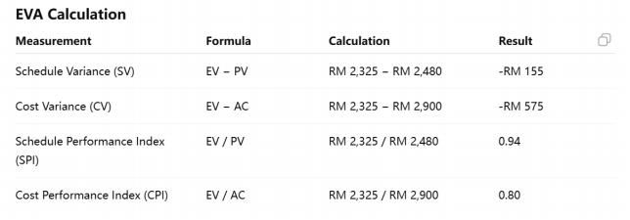

Interpretation

The EVA results indicate that the project is slightly behind schedule and slightly over
budget, as both SPI and CPI values are below 1. However, the project remains
manageable, and the team will continue monitoring progress using Jira and Gantt Chart tools to ensure successful completion.

10. Discussion & Challenges

10.1 Technical Issues

Technical Issues & Solutions
• API Integration Challenges: Relying on the DeepSeek API led to response delays and connection failures that impacted user experience.
• Connection Error Handling: The team implemented error handling mechanisms to provide users with fallback data or clear messages when external AI services were
unavailable.
• Data Retrieval Complexity: Variations and potential changes in RSS feed
structures required refined data parsing and validation to maintain the accuracy of the campus event display.
• Storage Limitations: Using JSON files for data management introduced risks regarding scalability and data consistency.
• Data Integrity Management: To prevent corruption or loss, the team carefully managed file reading and writing operations within the local JSON storage.

10.2 Team Coordination Issues

Team Coordination Challenges
• Task Coordination: Coordinating simultaneous module development (AI, Schedule, Events) was difficult, leading to consistency and integration challenges.
• Task Dependencies: Development delays occurred when specific tasks relied on the completion of other system components.
• Progress Tracking: Managing workload and monitoring individual module status required a centralized tracking approach.
• Jira Implementation: The team utilized Jira to assign tasks, track real-time progress, and ensure the project stayed on schedule.

10.3 Solutions and Improvements

• Technical Stability: The team enhanced error handling for API integration and implemented fallback mechanisms to maintain system stability.
• Data Reliability: Data validation techniques were applied during RSS feed processing to ensure the accuracy of retrieved information.
• Task Management: Jira was utilized to clearly assign tasks and monitor progress through list views and Kanban boards.
• Team Alignment: Regular group discussions facilitated quick problem-solving and ensured all modules remained aligned with system requirements.

Overall, these improvements enhanced both the system quality and the development process.

11. Conclusion

11.1 Summary of Project

The UKM Study Assistant is a web-based platform that centralizes academic management and campus information into a single interface. It integrates the DeepSeek API for real-
time AI assistance, an automated class reminder system, RSS-driven campus event
tracking, and navigation tools for both university websites and faculty maps. By utilizing
local JSON storage for schedules and chat history, the system provides a lightweight,
efficient solution that improves student productivity and simplifies the overall UKM campus experience.

11.2 Objectives Achievement

The project successfully achieved its objectives by implementing a centralized platform
that integrates AI-based interaction, schedule management, and campus navigation into a single system. The AI Chat Assistant delivers real-time responses via the DeepSeek API, while the Schedule Management module effectively handles class timetables and provides timely reminders.
Furthermore, the system successfully retrieves real-time campus events and enhances
resource accessibility through its navigation and map modules. With the inclusion of user profile customization and local JSON-based chat history storage, the final system meets all defined project scopes and functional requirements.

11.3 System Effectiveness

The UKM Study Assistant effectively addresses information fragmentation by integrating schedules, events, websites, and maps into a single platform. It improves time
management through automated tracking and reminders, helping students avoid missing classes.
The system enhances navigation for new students via dedicated map features, while the AI Chat Assistant provides instant, context-aware support. Overall, the platform increases efficiency and provides a practical solution to the common challenges faced by UKM
students.

12. References

The following materials were used to help define the requirements of this system:
1. Project proposal and requirement description for the UKM Study Assistant system
2. Streamlit Official Documentation
https://docs.streamlit.io/
3. DeepSeek API Documentation (for AI chatbot integration) https://platform.deepseek.com/
4. Python Standard Library Documentation (JSON handling) https://docs.python.org/3/library/json.html
5. Requests Library Documentation (used for web scraping) https://docs.python-requests.org/
6. XML Parsing Documentation (used for RSS data processing) https://docs.python.org/3/library/xml.html
7. Google News RSS Feed (used as the data source for campus events) https://news.google.com/rss
8. Python Web Scraping Techniques and Online Resources (used for implementing the campus event crawler)
9. Software Requirements Engineering lecture materials

